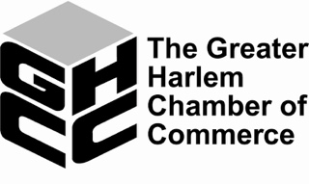

Harlem Week
2022 Minority Women-Owned Business Pitch Competition
Application

Applicant Information:

Business Name: __________________________________________________________________

Address: _________________________________________________________________________

Website Address: _________________________________________________________________

Contact Name: ___________________________________________________________________

Contact Email: ___________________________________________________________________

Phone Number: ___________________________________________________________________

Name of Business Pitch Presenter: _________________________________________________

Proposed Use of the Grant Award (What Technology Will You Purchase to Enhance
Energy Efficiency at Your Company?):

Please State the Impact this Award Will Have on Your Business:

I have read and agree to the Official Rules of the Competition, and attest to the truth and accuracy of the statements above.

Applicant’s Signature: ________________________________ Date: ____________________

Please submit applications at Carverapplications@carverbank.com

